EXPERIMENT 1: Comparative Study of Low-Code Development using Student Admission Form

Aim
To study the advantages of developing a Loan Application Form using Zoho Creator, a lowcode platform, and compare it with traditional programming methods.

Comparison Table

Traditional Development | Low-Code(Zoho Creator)
Write HTML, CSS, JavaScript for the form interface | Drag-and-drop form builder
Write backend code manually | Automatic database creation
Manual validation for fields | Built-in validation rules
Manual report and dashboard creation | Auto-generated reports
More coding knowledge required | Minimal coding required
Longer development time | Faster development
Separate integration for database and UI | Unified platform with form, database, and reports

SCREENSHOTS:

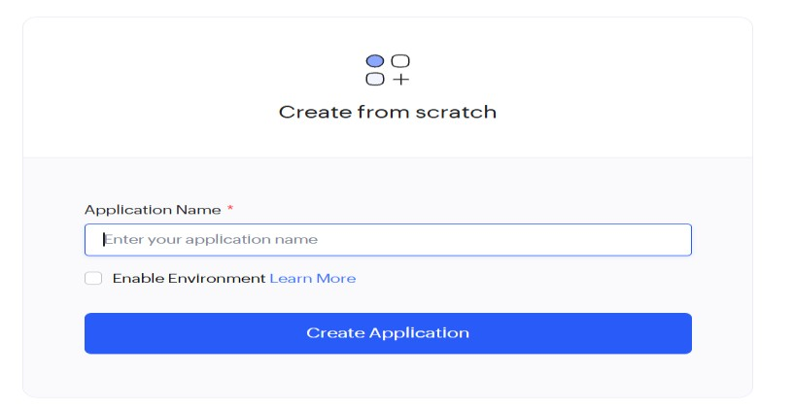

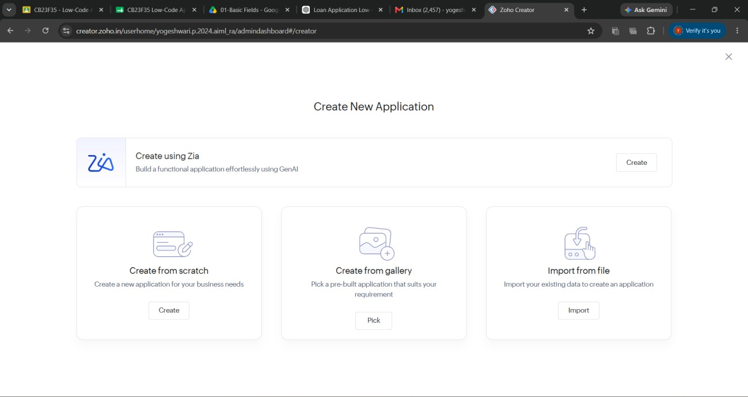

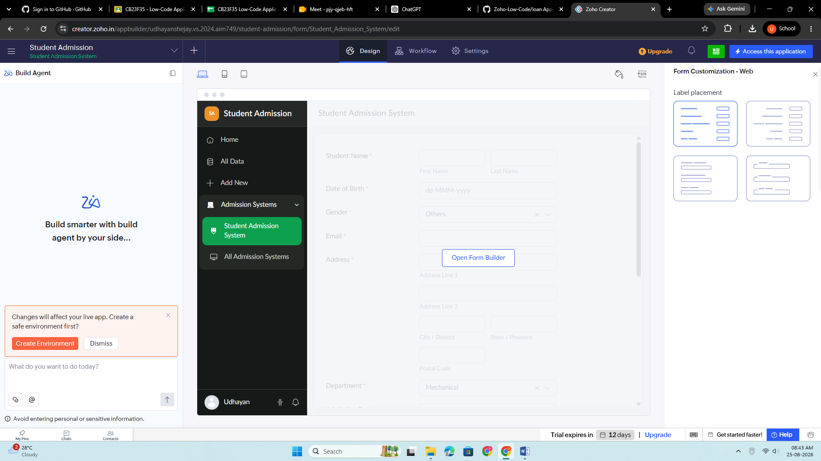

Observation
Developing the Loan Application Form using Zoho Creator is faster, easier, and requires minimal coding effort. The platform automatically handles database creation, field validation, report generation, and workflow management, making it highly suitable for banking and financial service applications.

Result
The Comparative Study of Low-Code Development using the Student Admission Form was completed successfully. The study demonstrated that Zoho Creator reduces development time, minimizes coding complexity, provides built-in validations, and simplifies report generation when compared with traditional programming approaches.

